**Week 9 of ENL distant learning lessons June 1st - June 5th**

**Monday June 1st**

**Objectives:** I can acquire new vocabulary and make inferences

Directions: Read the following story and answer the questions that follow it.

# Amira’s Song

Memories of Syria help Amira make a surprising discovery

[MARCH 2019](https://action.scholastic.com/issues/2018-19/030119.html)

By Nora Raleigh Baskin

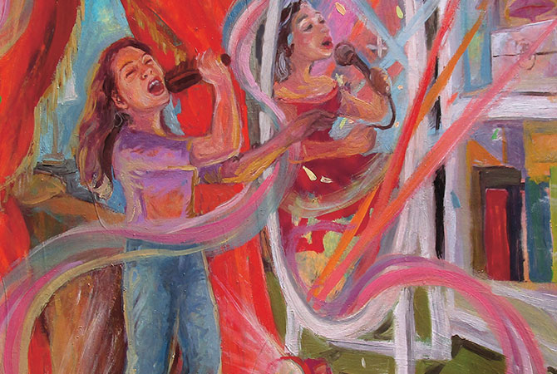

Part 1

Amira sang in her bedroom, standing at the edge of her rug. It became a stage where she could look out to an imaginary audience.

“Your music is so loud!” said Jibril. He burst in, letting the door hit the wall. “I told you I was trying to study.”

**The stage and the sound of the applause vanished. Even the microphone in Amira’s hands turned instantly back into a hairbrush. Her face burned with embarrassment.**

“Can’t you knock?” Amira asked.

“I can,” her brother said. “And I did. You didn’t hear me.”

“Sorry,” Amira said. She knew Jibril really did try to give her privacy. After all, it was his room too.

Jibril got the books he needed. But before he left, he turned around. “You do have a great voice,” he told her.

Amira wasn’t sure which was worse: getting caught singing, or being told she was good at it. In a funny way, her brother’s **compliment** scared her. **But it also made her heart thump with possibility.**

I do want to be a singer, she told herself. Then she sat down on her bed, knowing it would never happen. Singers can’t be afraid to sing in front of real people—and Amira was.

## PART 2

Part 2

So Amira turned her attention to her school project, International Day. Each seventh-grader had to choose a country, provide information about it, and decorate a table. On the night of the big event, they would make a presentation to anyone who stopped by.

Amira thought back to when Mr. Veitro had assigned the project. Everybody had called out their country: China. India. Ireland. Some people wanted the country their families had come from. Others chose a country just because they liked the food or the soccer team.

“Amira, can I count on you for Syria?” Mr. Veitro asked.

Everyone knew that Amira and her family had **emigrated** from Damascus, in a country called Syria. That was six years ago. **But Syria was so often in the news now because of the war there**. People always asked Amira questions.

Shutterstock.com

Was your house bombed? No. Did you see the war? A little. Can you speak **Arabic**? Sort of. Do you still have family there? Yes.

Some of Amira’s memories of her life in Syria were fading. She couldn’t remember much about her old room—except that it was bigger and she didn’t have to share it. But one memory still filled her heart: her grandmother’s love. Her grandmother was the first one to sing with Amira. **When Amira sang with her grandmother, her voice felt strong**. They would sing folk songs, pop songs, lullabies.

The night before she and her family left for the United States, Amira couldn’t sleep. Her grandmother sat by her bed. “Tayta, why can’t you come with us?” Amira had asked.

“It’s not that I can’t,” her grandmother had told her. “But this is my home. If you don’t come back soon, I’ll come to you. Soon.”

They talked on the phone almost every month for a year. Amira always asked her grandmother the same question. When is soon? Then one day, the family got a heartbreaking call. Tayta had died. No one spoke. They were all thinking about how badly they wished she had come with them.

## PART 3

Part 3

“I picked Syria for my International Day project,” Amira told her family at dinner.

Her father nodded. Her mother smiled. “Do you need any help?”

In Damascus, they had been doctors. Here, Amira’s mother was a medical assistant and her father worked in a research lab. They both spent long hours at work. Asking her mother to help with a school project would be asking too much.

**“No, I’m good,” Amira answered.**

iStock/Getty images

In class, Mr. Veitro gave them time to do research on the computer. Amira wrote down facts about Syria’s history and its many languages and religions. But there was a lot about the war, and some of that was too painful to read.

Mr. Veitro suggested that students make a special food from their country. So the day before the event, Amira cut up pita bread and made hummus. She roasted the chickpeas and the garlic. And as she mashed it all up, she sang to herself. It was a Syrian song her grandmother had taught her.

No one was home, and she sang it over and over. She sang really loud—until she could almost hear her grandmother’s voice joining in.

When she was done, Amira dipped her finger into the bowl of hummus. **It tasted perfect.**

## PART 4

Part 4

That night, Amira tried to convince her parents that they didn’t have to come to the school event. Her father just kissed the top of her head: “We’ll be there around 7:30.”

Amira couldn’t believe what she saw when she walked into the gym. **The entire floor was taken up with long tables. Each one was covered in fabric matching the colors of a country’s flag**.

The India table was one of the most colorful. It looked like Divya’s entire family was there, all dressed in traditional Indian outfits. At the China table, there were spring rolls and **intricate** paper cut-outs. Canada had a big platter of pancakes and a huge jug of maple syrup. The Philippines table even had a roof of dried grass.

iStockPhoto/Getty Images

Amira set down her plastic bowl of hummus and her paper plate of pita bread. She stood her poster board on the table and slumped down into her chair. She didn’t want her parents to see what a terrible job she had done. Why hadn’t she done more to honor Syria, her family, her grandmother’s memory?

“Don’t worry about it,” Jibril said with a **reassuring** smile. “I’ll go wait at the entrance for Mom and Dad.” **Amira nodded.**

A few people admired her homemade hummus. They politely listened to her presentation. Then they quickly moved on to Ireland, where a family was giving away potato chips and shamrock stickers.

Part 5

Amira felt like crying. Instead, she closed her eyes and began to quietly hum the Syrian song her grandmother had taught her.

Then, ever so softly, she began singing the words. It was so loud in the gym that she couldn’t even hear herself. She kept her eyes squeezed shut and imagined that she was in the kitchen with her grandmother. Amira’s full voice rose out of her chest. It was as if her grandmother was with her, singing each Arabic word.

When she finished, it was the silence that startled Amira. Then the clapping. Then the cheers.

“Bravo, bravo! How beautiful!”

“Where did you learn to sing like that?”

How long had they been listening? How long had she been singing?

Mr. Veitro was wiping his eyes. “Amira, that was incredible. You captured the true meaning of this project with your voice.”

She didn’t have time to be embarrassed. Or afraid. She didn’t have time to do anything but smile. And there in the crowd were her mother and father and Jibril—their eyes shining with tears.

Vocabulary

Directions: Choose the best word from the word bank to complete each sentence.

1. Six years ago, Amira ______________________ from Syria with her family.

2. Amira remembers how to speak some ___________________, but many other things about her life in Syria are getting harder to recall.

3. Amira’s Syria presentation for International Day is small and simple, but other students created ___________________ crafts for their displays.

4. She’s ashamed of her display, but her brother’s smile is __________________.

5. To feel better, Amira sings a song her grandmother taught her, and she receives one __________________ after another for her beautiful singing.

Directions: Fill in the bubble next to the best answers for questions 1-6.

1. The line “the microphone in Amira’s hands turned instantly back into a hairbrush” shows you that Amira ______.

A knows magic

B has a good imagination

C is tired of taking care of her long hair

D is making a music video

2. In the phrase “Everyone knew that Amira and her family had emigrated from Damascus,” emigrated means ______.

A became sick

B got food

C learned

D moved

3. Which did Amira make for International Day?

A pancakes

B paper cut-outs

C hummus

D a traditional outfit from Syria

4. In the gym, how does Amira feel at first about the presentation she prepared?

A ashamed

B proud

C excited

D bored

5. Which line from the story supports your answer to question 4?

A “Everybody had called out their country . . .”

B “She didn’t want her parents to see what a terrible job she had done.”

C “It tasted perfect.”

D “. . . some of that was too painful to read.”

6. Amira solves her problem of being too afraid to sing in front of others by ______.

A singing as fast as she can

B choosing a sad song to sing

C pretending that her bedroom is a stage

D imagining that her grandmother is singing with her

7. Give two details from the story that show Amira’s close relationship with her grandmother.

8. Why is Amira smiling at the end of the story?

# Tuesday and Wednesday June 2 – June 3

# Why I Wear a Head Scarf

Soha, 16, is one of 3.4 million **Muslim** people in the United States. She chooses to wear a head scarf to honor her religion. Here’s what that means.

[NOVEMBER 2018](https://action.scholastic.com/issues/2018-19/110118.html)

By Soha Manzoor, as told to Jessica Press

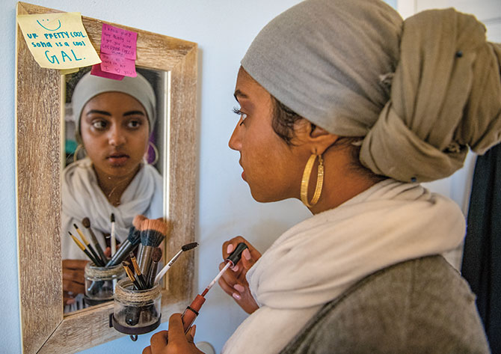

In many ways, I’m a typical American teen. I play tennis for my school team. I love reading Harry Potter books and watching Marvel movies. I wear makeup, watch Netflix, listen to music, and study.

But I do it all in a **hijab**. That’s another name for the head scarf I wear every day.

My hijab is always with me. I wear it to school and on weekends. I wear it to Starbucks and to tennis practice. The only time I don’t wear it is at home.

I live in sunny California. So why do I wear a head scarf all year? People ask me that question all the time.

The short answer is that my hijab is just a part of who I am. The long answer has to do with my religion.

## Deep Connection

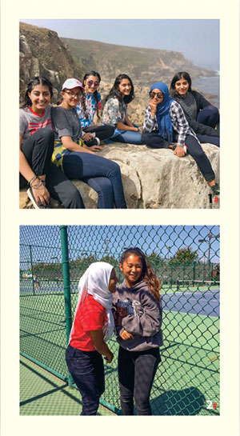

Courtesy of Family

[**Hanging Out**  
1. Soha poses with friends on a camping trip.  
2. Soha and her best friend take a break from tennis.](https://action.scholastic.com/issues/2018-19/110118/why-i-wear-a-head-scarf.html)

My family and I are Muslim. In other words, we practice Islam. Islam is one of the world’s largest religions. It has many beautiful traditions.

I love going to the mosque, the Muslim place of worship. I like the spicy foods we eat when we’re together. And I like going to religious classes twice a week.

In class, we use a book called the Koran (kuh-RAN). It’s the holy book for Muslims. We study it, just as Christian people study the Bible or Jewish people study the Torah.

My religion has taught me important lessons. Muslims believe that all people are equal and that we should help each other.

A Proud Decision

I decided to start wearing a hijab in sixth grade. In Islam, the hijab is a way to show modesty. No one has to wear one. It’s a choice. For me, it was a way to show the world that I’m Muslim and proud.

I remember the night before I wore a hijab to school for the first time. I felt really nervous. I messaged my friends ahead of time. I didn’t want them to be surprised.

The next day at school wasn’t so bad. Sure, people asked about my hijab. But I’m glad they did. Not asking questions is what leads to prejudice.

Many people think Islam teaches violence. They also think Muslims don’t treat women equally. That’s not true. Wearing a hijab gives me many chances to teach people about Islam.

Part of Me

Courtesy of Family

Family First   
Soha lives in California with her   
two sisters, her dad, and her mom (not pictured).

I’ve been wearing the hijab for five years now. Putting it on in the morning is a normal thing, like doing my hair. When I get home, I take it off. It’s a part of who I am.

Praying is also a part of who I am. Muslims do five daily prayers at specific times. Sometimes I have to stop my tennis match to pray. I’ve also prayed in restaurants and on the sidewalk outside of school.

Once, my friends and I were at an arcade. When I stopped to pray, a woman started making weird faces at me. My friends told her to stop.

My closest friends are not Muslim. But they support me and my religion. They even try the spicy foods! I’m lucky to have these friends in my life.

Making friends with people who seem different is important. Sticking by them is too. It makes all of us stronger.

Directions: answer the following questions in complete sentences.

1. Does Soha wear a hijab at home?
2. Did she feel nervous the first time she wore a hijab at school?
3. Does Soha take off her hijab during the summer vacation?
4. Did she stop playing tennis when she started wearing the hijab?
5. Do Soha’s friends support her religion?
6. When did Soha start wearing a hijab?
7. Does she have to wear a hijab or is it her choice?
8. Where does Soha pray?
9. Why does Soha wear a hijab?
10. What are three traditions of Islam?

Thursday and Friday June 4 – June 5

Objectives: I can find text evidence and know the differences between their, there, and they’re

Directions: Read the following story and answer the questions the follow it.

She Lived on Mars! (Sort Of)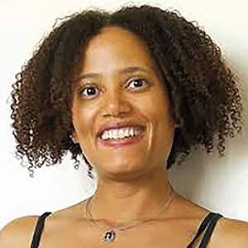

Dr. Sian Proctor’s job is to survive in outer space. But she never actually leaves Earth. How is that possible?

It was a beautiful day when Dr. Sian [sy-AN] Proctor came back from Mars. For the first time in four months, she and the five other crew members could go outside without spacesuits. Sian squinted in the sun and felt the wind on her face. How amazing to finally be home!

Except Sian and the rest of the crew never actually left Earth. That’s because they are analog astronauts. Their Mars mission was a simulation—something made to look and feel like something else. In this case, Sian’s crew lived in Hawaii. Scientists chose the location because it has land that is similar to Mars.

While there, Sian slept inside a small white dome. She took two-minute showers to save water. And she couldn’t call or text her family. We talked to Sian about why her job is important.

**What is the purpose of analog astronauts like you?**

Basically, we’re testing space missions here on Earth. We’re learning how to make food in space. We’re seeing how people get along when they’re stuck together for a long time. We test things like spacesuits and robots to make sure they will actually work in space.

**Who can become an analog astronaut?**

Anyone who loves space! Some are scientists, like me. Others are artists, teachers, and doctors. An analog astronaut’s goal is to help humans prepare to start new communities on the moon or on Mars. In those communities, we’ll need all types of people.

**What is the most surprising thing you have learned in your job?**

Many of the things we have to do to survive in space are good lessons for living on Earth too. We have to save water and electricity. We also have to be really careful with our food and not waste anything.

**What traits make someone a good analog astronaut?**

Teamwork is the most important thing! You also have to be calm and deal with stress well.

**What would you say to kids who want to be astronauts?**

You can be an analog astronaut right at home. You can buy freeze-dried foods and learn to cook like an astronaut. I even have a YouTube series called Meals for Mars to get you started!

Questions

1. Sian talks about how astronauts have to be calm. What is another word for calm?
2. What are two things that astronauts have to do in space that are good to do on Earth too?
3. Why did the Mars simulation take place in Hawaii?

Directions: Each sentence below is missing the word their, there, or they’re. Read the rules, and then fill in each blank with the correct word.

Rules for using their, there, and they’re

1. Use THEIR to mean “belonging to them.” Example: Their Mars mission was a simulation—something made to look and feel like something else.

2. Use THERE to mean “that place” and in phrases like “there are” and “there will.” Example: While there, Sian slept inside a small white dome.

3. Use THEY’RE to mean “they are.” Example: We’re seeing how people get along when they’re stuck together for a long time.

1. I love my cousins, but __________ kind of crazy.

2. I mentioned Mars to my cousin Alexa, and she said, “I’m going to live __________ someday.”

3. “I think it costs a lot of money to get __________ ,” I told her.

4. “That’s OK,” she said. “I’ll sell my dolls. __________ worth a lot.”

5. I think __________ might be a problem with Alexa’s plan.

6. Most of her dolls are missing __________ hair because she gave them haircuts.

7. Alexa and her sisters don’t treat __________ things very well.

8. If they want to get to Mars, __________ going to have to find another way.